**EC2 Basics Lab**

* **Objective:** To understand the process of setting up and managing an Amazon EC2 instance.
* **Approach:** Students will start by launching a new EC2 instance, selecting an appropriate instance type and configuring the instance details. They will then create and configure a new Security Group, and allocate an Elastic IP address to the instance. The lab will also include connecting to the instance via SSH.
* **Goal:** By the end of this lab, students should be able to launch and manage an EC2 instance, understand instance types, security groups, and IP addressing in AWS.

**STEPS**

First open the AWS Console and click on EC2 instance and provide the EC2 instance name, then after that select OS image and AMI which is shown in the image below.

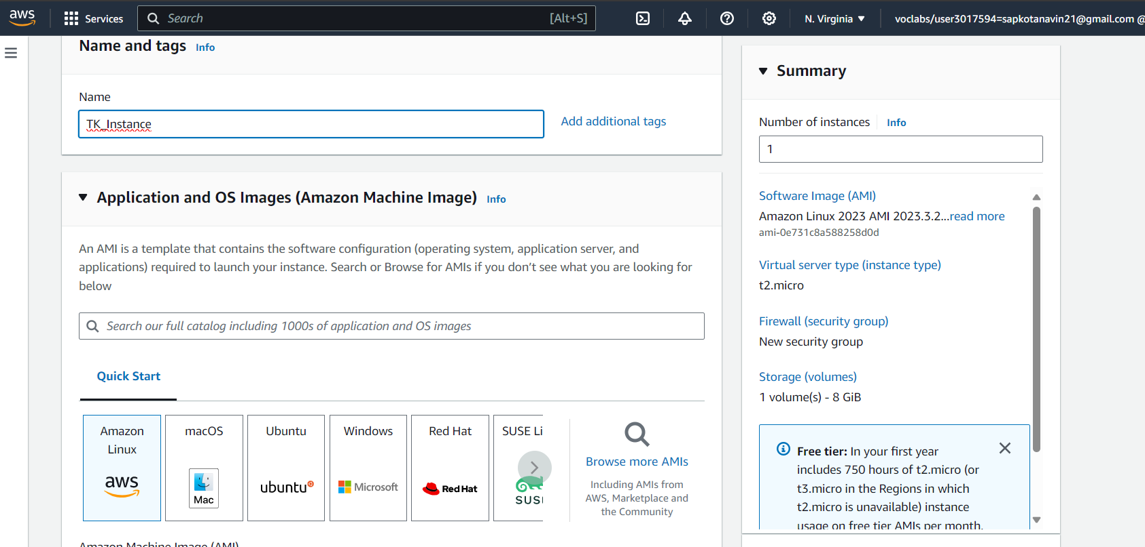

Choose the instance type and select keypair name for login. After that create security group and make the required changes to the set of rules there as per requirement. Disable the auto assign Public IP and after that launch the EC2 instance.

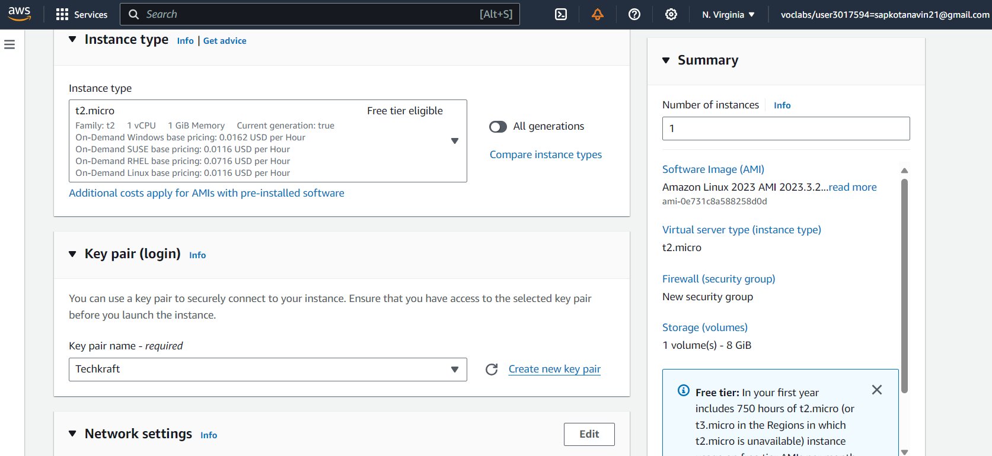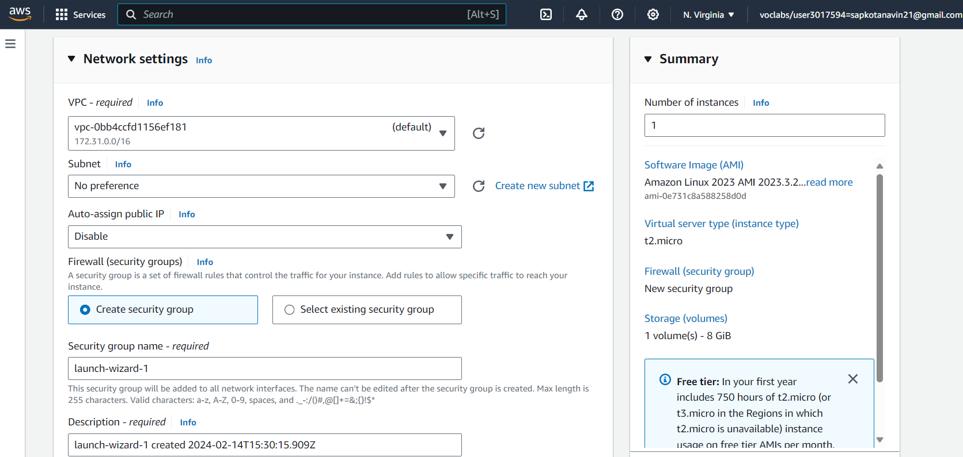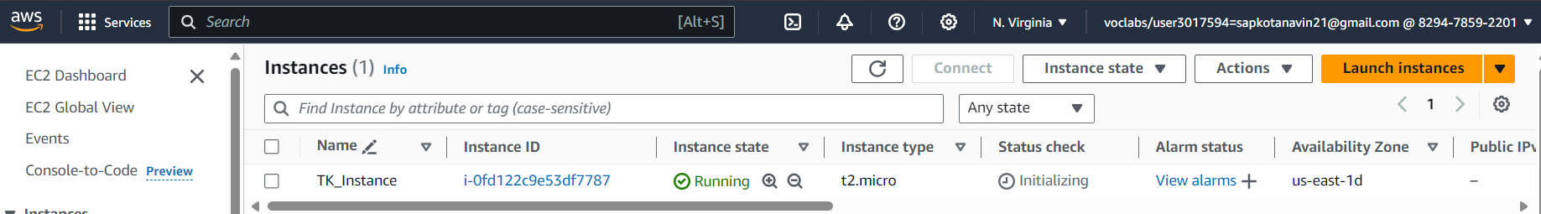

For assigning the IP address, we will do elastic IP address allocation.

Navigate to the "Elastic IPs" section under "Network & Security" in the EC2 Dashboard.

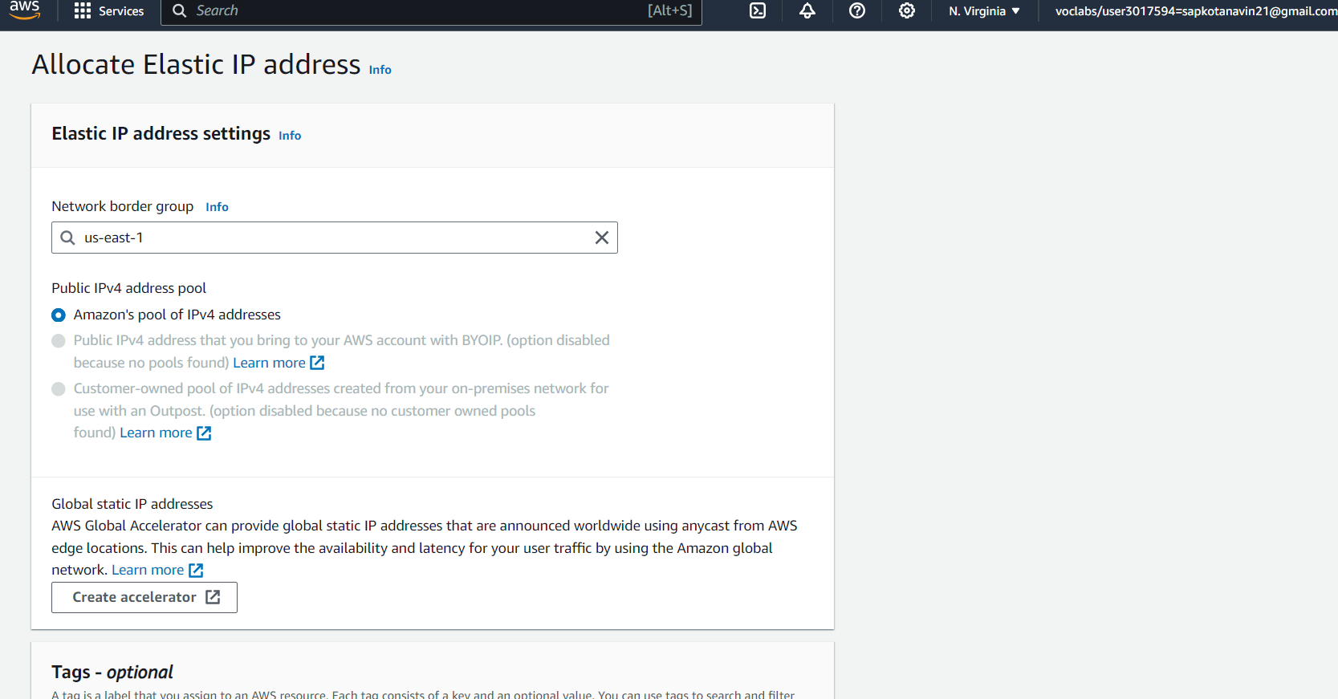

Associate this Elastic IP address with your EC2 instance to ensure it has a static public IP.

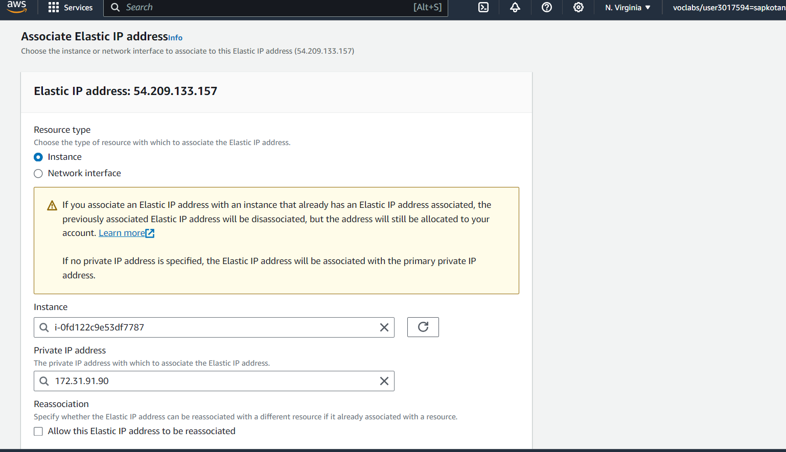

Here is the Instance summary.

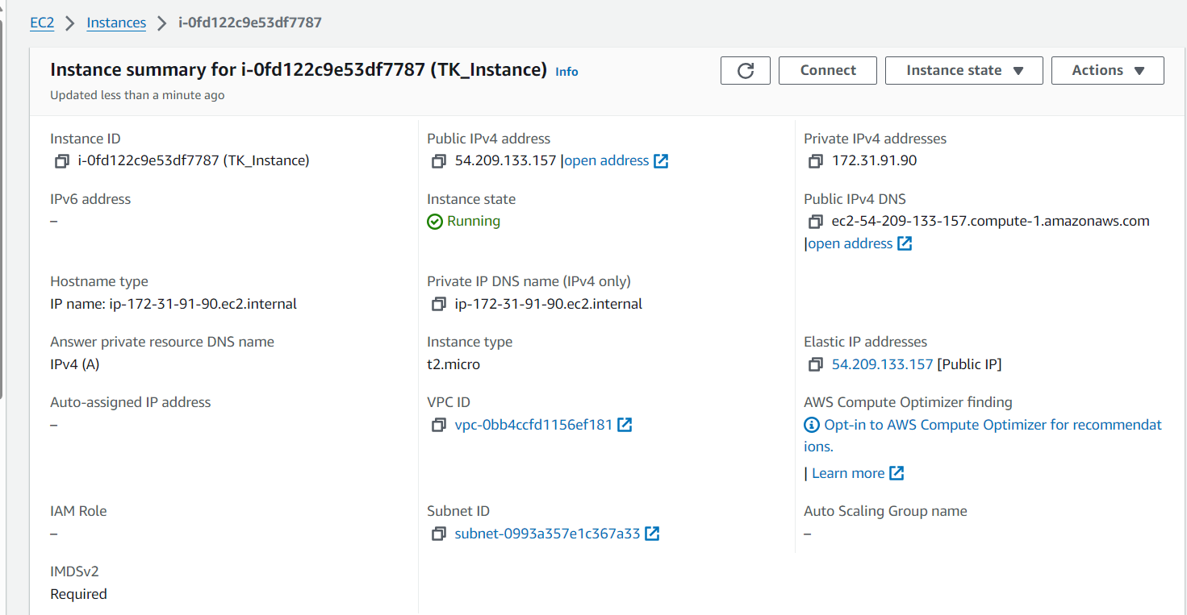

Now, Use SSH client to connect to your EC2 instance using the Elastic IP address and the private key associated with the key pair you selected or created earlier. 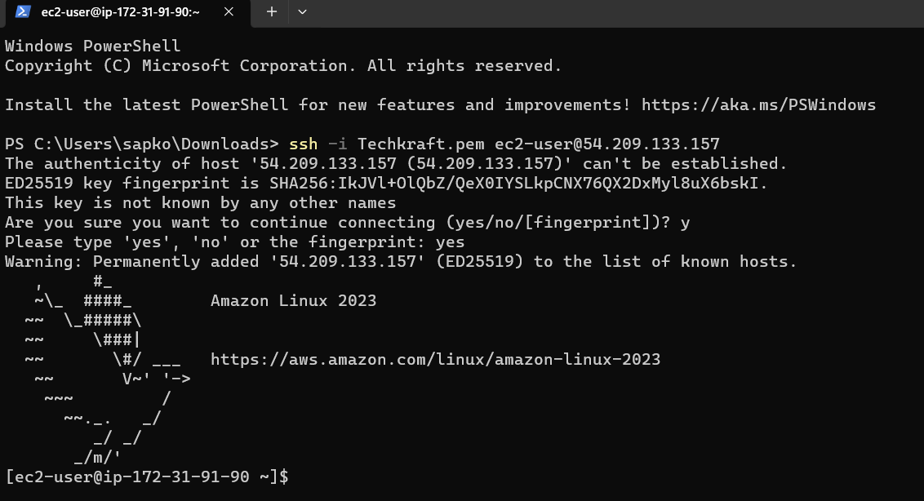

**S3 Storage Fundamentals Lab**

**Objective:** To gain hands-on experience with Amazon S3 by performing basic storage operations.

**Approach:** This lab involves creating an S3 bucket, uploading files to it, and setting up bucket policies for access control. Students will explore the S3 management console, learn about object storage, and understand the concepts of buckets and objects.

**Goal:** Students will understand how to use S3 for storing and managing data, learn about S3 security and permissions, and become familiar with S3's user interface.

**STEPS**

Go to the AWS Console Management and select S3 Click create bucket to create the S3 bucket. Provide S3 bucket with a unique name. 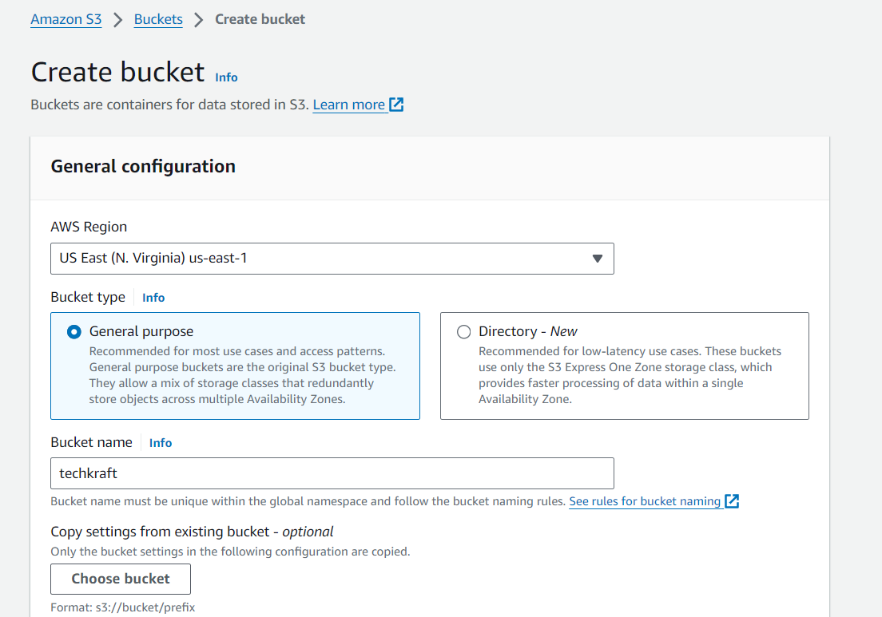

Once the bucket is created, click on its name to open it.

Click on the "Upload" button.

Select the files you want to upload from your local machine.

Click "Upload" to upload the files to your bucket.

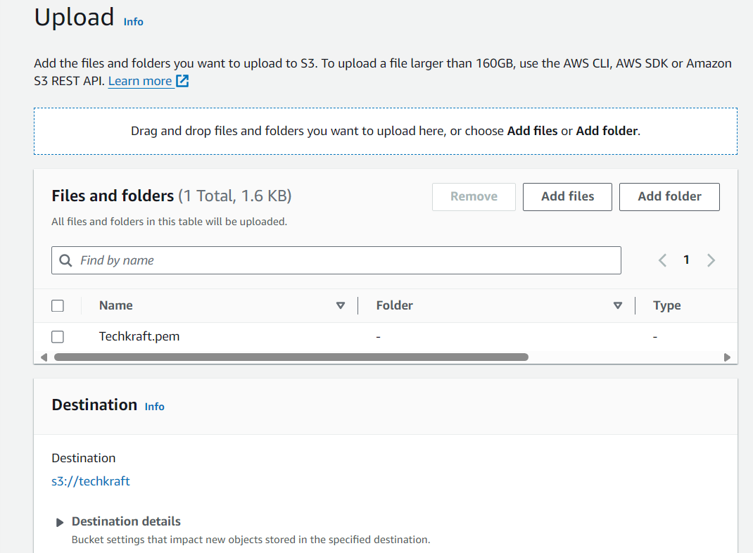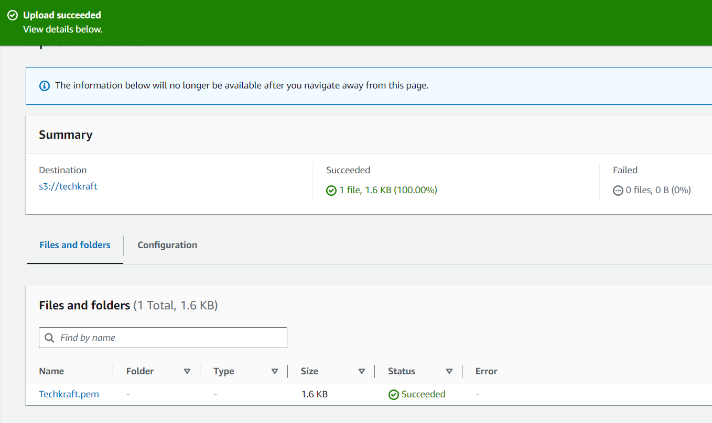

**Set Up Bucket Policies:**

In the bucket overview page, click on the "Permissions" tab.

Under "Bucket Policy", click on "Edit".

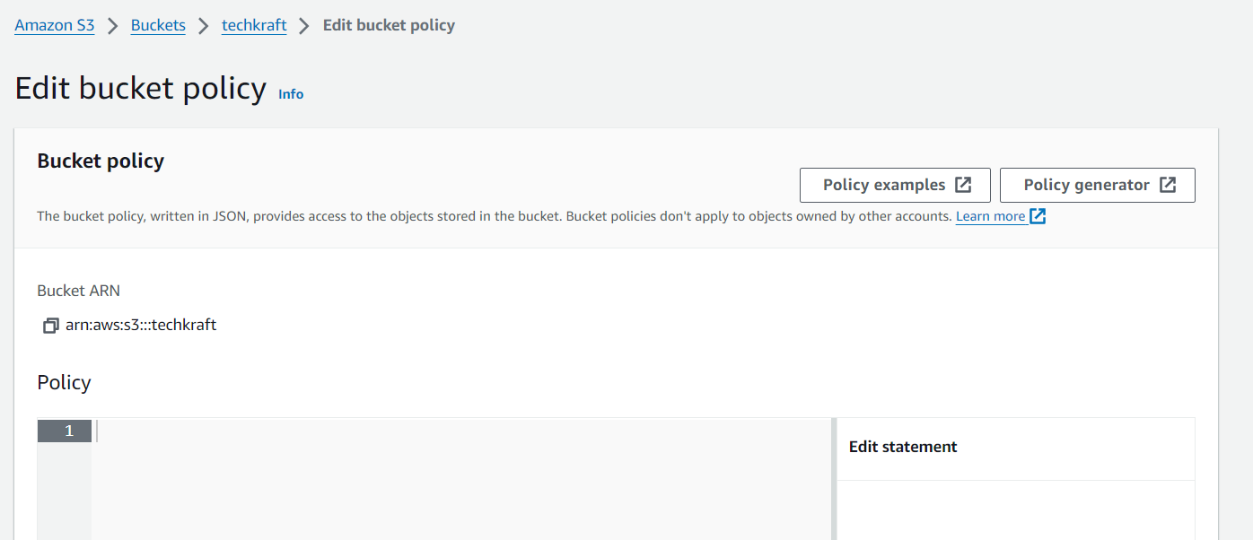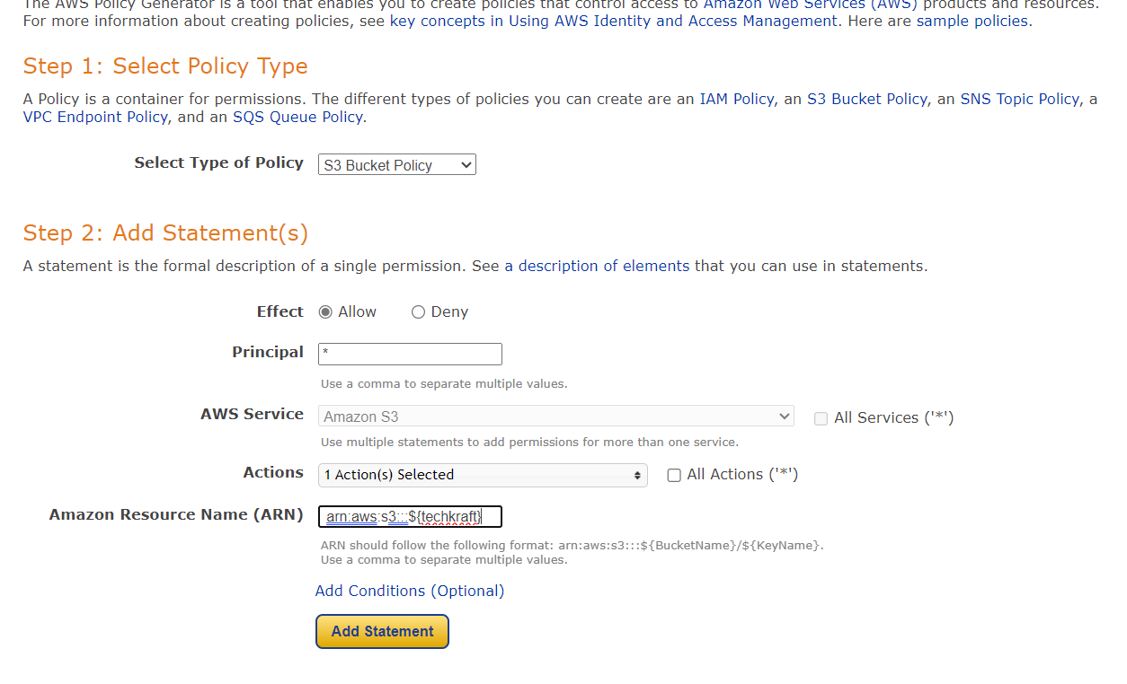

Write or paste a bucket policy that defines who can access your bucket and under what conditions. For example, you can allow public read access to all objects in the bucket. 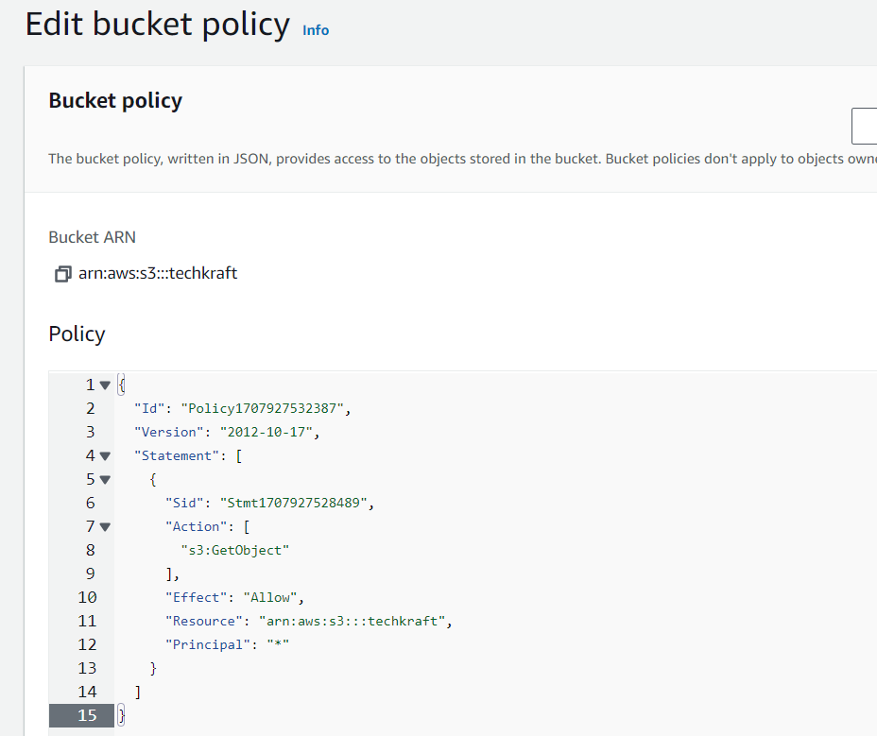

Click "Save changes" to apply the bucket policy.

**VPC Configuration Lab**

**Objective:** To understand the fundamentals of AWS networking through the configuration of a Virtual Private Cloud (VPC).

**Approach:** Students will create a new VPC, add subnets, set up an Internet Gateway, and configure route tables. The lab might also include setting up a simple EC2 instance within this VPC to demonstrate how resources are deployed in a custom network environment.

**Goal:** By the end of this lab, students should be able to create and configure a VPC, understand subnetting, and the role of route tables and internet gateways in AWS

**STEPS**

Navigate to VPC Dashboard

Once logged in, navigate to the VPC Dashboard by selecting "Services" at the top left corner and then clicking on "VPC" under the "Networking & Content Delivery" section.

Create a VPC

- Click on "Create VPC" to start creating a new VPC.

- Enter a name for your VPC and specify the IPv4 CIDR block

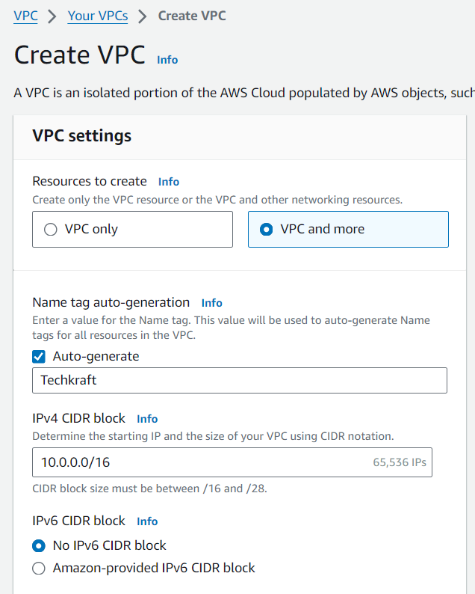

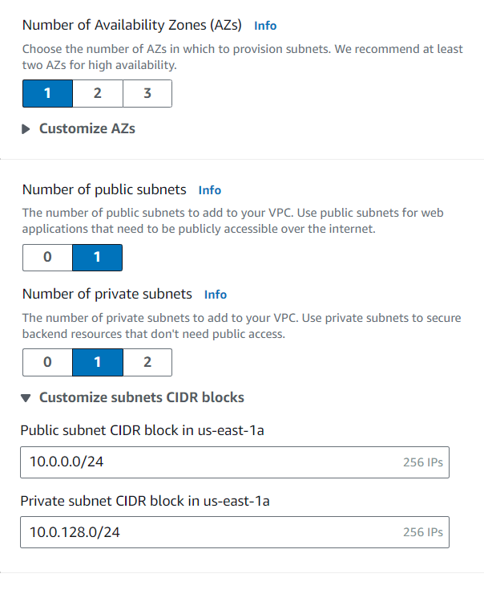

Click "Create" to create the VPC.

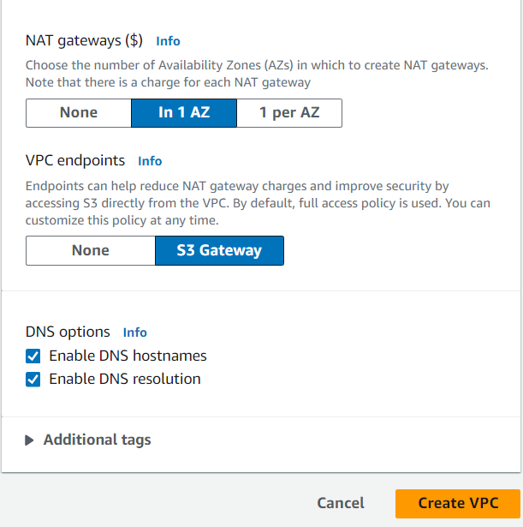

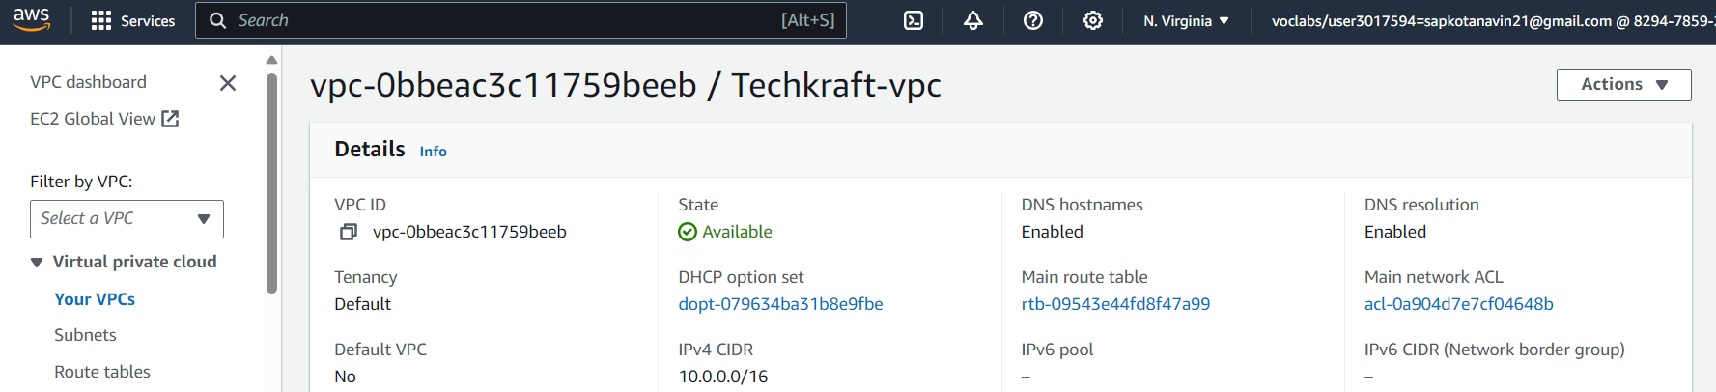

**Add Subnets**

- After creating the VPC, click on "Subnets" in the left navigation pane.

- Click on "Create subnet" to add a new subnet.

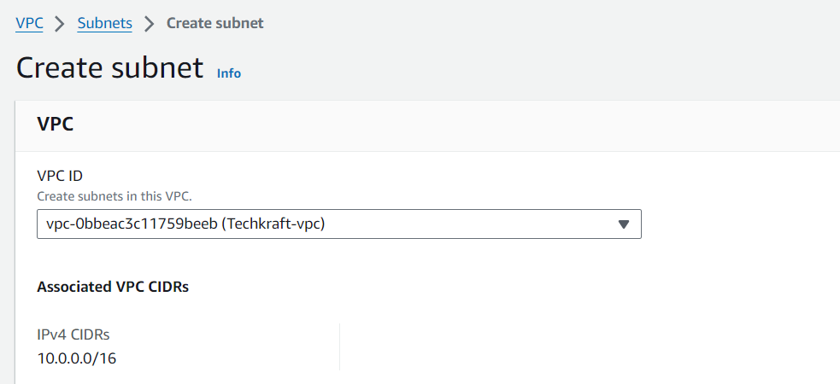

Enter a name for the subnet, select the VPC you created earlier, and specify an IPv4 CIDR block for the subnet.

- Click "Create" to create the subnet.

